A Souvenir with a Moveset
Description | My friend got this invitation to a launch party of some Digimon game. He apparently got a free monster that had a curved horn and was holding a "Ganlon Berry"? It's also somewhat rare because it came with a move that it normally couldn't learn from the original game? I really want to know what move that was; can you tell me the English name of that special move?
Files | invitation.jpg — one original promotional leaflet. Submit RCC{move_name}.  Period leaflet preserved by DanTrain1 and PokéHistorian. Original Pokémon/Nintendo promotional material; rights remain with the respective owners.
Hint(s) | 1. The invitation identifies a real event. The creature description identifies a species; the berry distinguishes the gift.  2. This was a Pokémon downloaded at the store's station, not a reward earned inside the Box software.  3. The promotion included two Absol variants. Preserved event records distinguish the Ganlon-bearing one from the Salac-bearing one.
Walkthrough | 1. Read the invitation: Pokémon Center New York, Pokémon Box, July 10, 2004. The white Pokémon with a curved horn is Absol.  2. Search for the Pokémon Box launch promotion. The leaflet's reverse advertises a download at the Gotta Catch 'Em All station. The contemporary Pokémon.com announcement also mentions the special download.  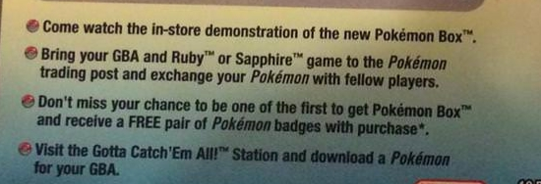  3. Find the Pokémon Box section of PokéHistorian's Generation 3 campaign research. Its Ganlon Berry Absol has Wish; the Salac Berry version has Spite. The berry in the description selects Wish.    4. Cross-check the preservation register, under Inkydog26 Collection → Pokémon Box. It lists PCNYd 00200 Wish Absol alongside other Wish and Spite examples. These collection records support the move; the official invitation does not name it.  
Flag | RCC{wish}

